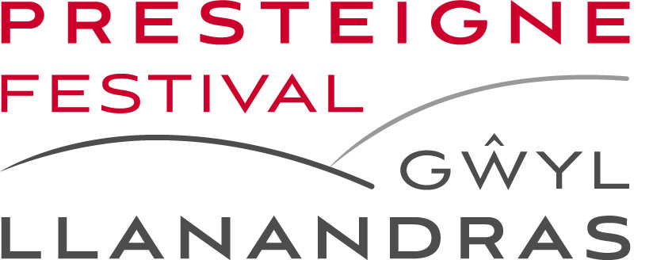

Supporting the 2024 Presteigne Festival
Our family of philanthropists continues to flourish, providing vital income for the organisation. We very much appreciate this support and hope that you will wish to continue your association with the Presteigne Festival in 2024. Our schemes offer extremely generous benefits and, if you feel able to make an additional donation, please indicate in the box at the foot of this form. Please make payments online if possible.

To: alisongiles@presteignefestival.com
or Alison Giles, Festival Producer, Presteigne Festival, P O Box 30, Presteigne, Powys LD8 2WF
Please tick one of the following boxes and send the completed form below (by email or post), together with your payment (Cheques to Presteigne Festival | Bank transfers to Presteigne Festival, Sort code: 40-26-21, Account number: 9111 6290, Ref: Quote your surname) to Alison Giles as above.
I /we would like to support the 2024 Presteigne Festival as follows:
□ Joint Festival Benefactor and enclose payment of £850
□ Single Festival Benefactor and enclose payment of £425

□ Joint Festival Patron and enclose payment of £650
□ Single Festival Patron and enclose payment of £325

□ Friend and enclose payment of £75

□ Festival Orchestra Chair (principal) and enclose payment of £750
□ Festival Orchestra Chair (sub-principal) and enclose payment of £500

□ I would like to make an additional gift of £ _____________
□ I would like GiftAid to be claimed on my behalf (Festival Benefactors or further donations only)

A GiftAid declaration form will be sent by email if this box is ticked, unless you are already registered.

Name ______________________________________________________________________________________________________________

Address ____________________________________________________________________ ________________________________________

__________________________________________________________________________ Post code ______________________
Telephone _____________________________________ Email ___________________________________________________________

This form is provided as a word document this year, so should be easier to complete, however, please contact alisongiles@presteignefestival.com if you have a problem, or would like to submit your membership another way.

